6.3.4 Packet Tracer - Troubleshoot EtherChannel
Objectives
- Part 1: Examine the Physical Layer and Correct Switch Port Mode Issues
- Part 2: Identify and Correct Port Channel Assignment Issues
- Part 3: Identify and Correct Port Channel Protocol Issues

Background
A junior technician recently configured four switches. Users are complaining that the network is running slowly, and they would like you to investigate.

Port Channel Table
Channel Group | Ports | Protocol
1 | S1: G0/1, G0/2 | LACP active
 | S3: G0/1, G0/2
2 | S2: G0/1, G0/2 | LACP active
 | S4: G0/1, G0/2
3 | S1: F0/23, F0/24 | LACP active
 | S2: F0/23, F0/24
4 | S3: F0/23, F0/24 | LACP active
 | S4: F0/23, F0/24
5 | S1: F0/21, F0/22 | LACP active
 | S4: F0/21, F0/22
6 | S2: F0/21, F0/22 | LACP active
 | S3: F0/21, F0/22

Device | Group | Ports
S1 | 1 | G0/1, G0/2
 | 3 | F0/23, F0/24
 | 5 | F0/21, F0/22
S2 | 2 | G0/1, G0/2
 | 3 | F0/23, F0/24
 | 6 | F0/21, F0/22
S3 | 1 | G0/1, G0/2
 | 4 | F0/23, F0/24
 | 6 | F0/21, F0/22
S4 | 2 | G0/1, G0/2
 | 4 | F0/23, F0/24
 | 5 | F0/21, F0/22

Instructions

Part 1: Examine the Physical Layer and Correct Switch Port Mode Issues

Step 1: Look for access ports.
Examine the switches. When two or more redundant links connect the same switches, Spanning Tree protocol will only put one port in forwarding mode to prevent switching loops. You can see this in Packet Tracer. When physical ports are assigned to an EtherChannel port, they behave as one logical port. Each pair will either be operational or down.

Step 2: Verify ports are in trunk mode.
- Verify that all physical ports in the topology are configured as trunks. Correct any ports that are in access mode.

S1 | 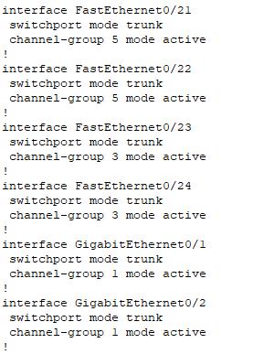  All interfaces are configured as trunks.
S2 | 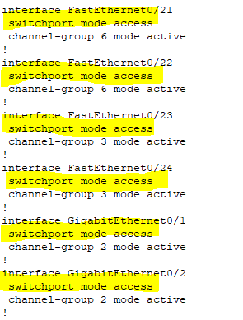  S2(config)#int range f0/21-24, g0/1-2  S2(config-if-range)#switchport mode trunk  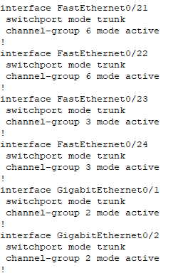
S3 | 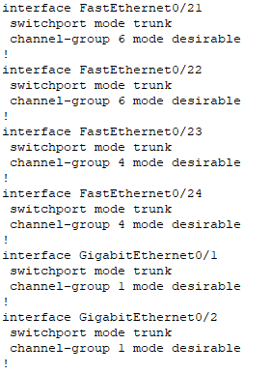  All interfaces are configured as trunks.
S4 | 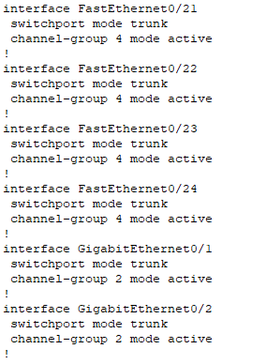  All interfaces are configured as trunks.

- Correct any EtherChannel ports that are not configured as trunks.

S1 | 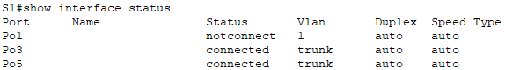  S1(config)#interface port-channel 1  S1(config-if)#switchport mode trunk  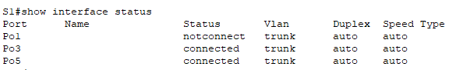
S2 | 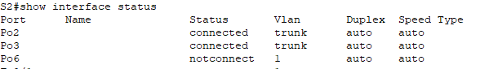  S2(config)#interface port-channel 6  S2(config-if)#switchport mode trunk  S2(config-if)#end  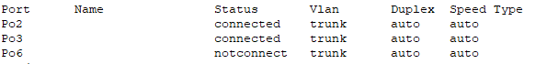
S3 | 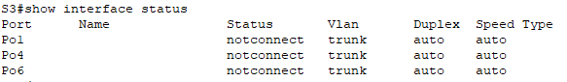
S4 | 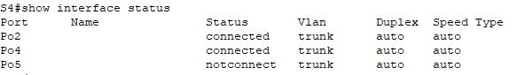

Part 2: Identify and Correct Port Channel Assignment Issues

Step 1: Examine port channel assignments.
The Packet Tracer topology and the Port Channel and Device tables provide details about the physical ports and their EtherChannel assignments. Use the show etherchannel summary command to learn how the EtherChannel links are configured. Verify that the switches are configured as shown in the documentation.

S1 | 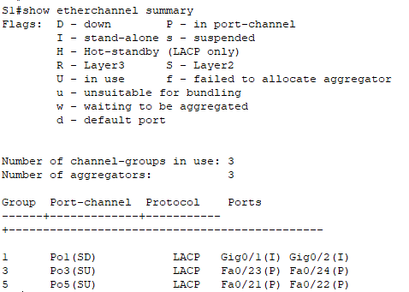
S2 | 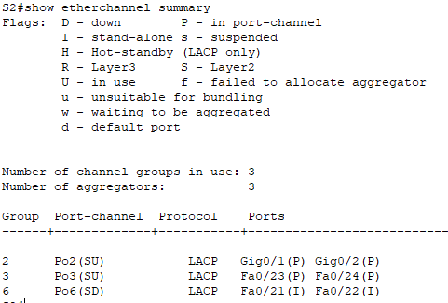
S3 | 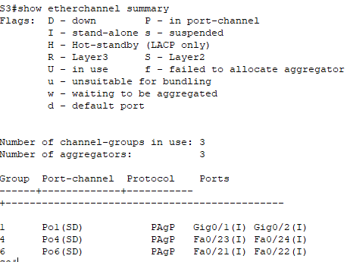
S4 | 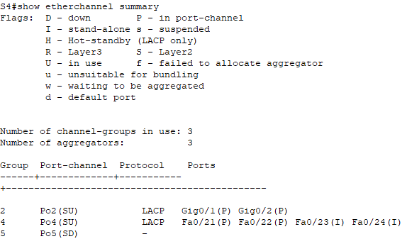

Step 2: Correct port channel assignments.
Correct any switch ports that are not assigned to the correct EtherChannel port.

S4 | 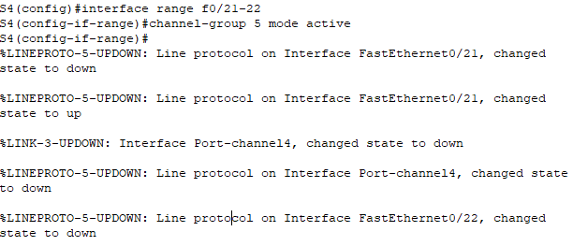  S4(config)#interface range f0/21-22  S4(config-if-range)#channel-group 5 mode active  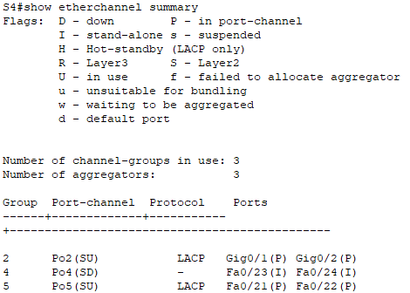

Part 3: Identify and Correct Port Channel Protocol Issues

Step 1: Identify protocol issues.
In 2000, the IEEE released 802.3ad (LACP), which is an open standard version of EtherChannel. For compatibility reasons, the network design team chose to use LACP across the network. The design team has made it a requirement that all ports that participate in EtherChannel need to actively negotiate the link as LACP. Verify that the physical ports are configured as indicated in the topology and Port Channel Table.

S3 | 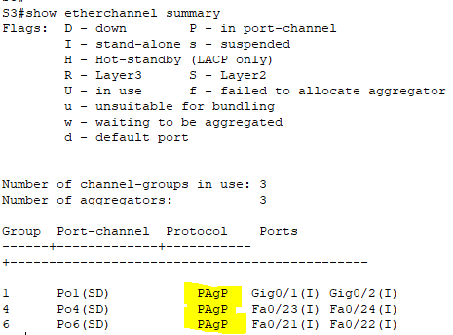

Step 2: Correct Protocol issues.
- Correct any switch ports that are not negotiating using LACP.

S3 | 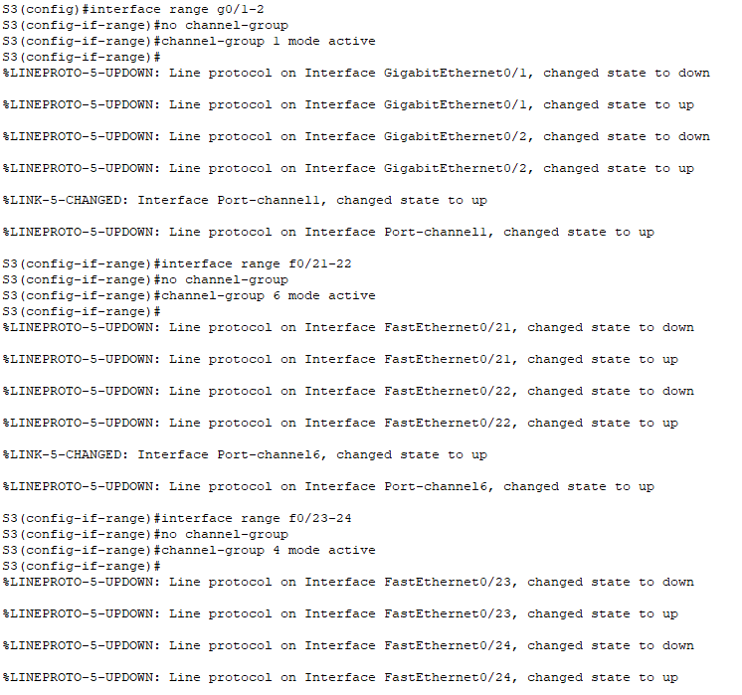  S3(config)# interface range g0/1-2  S3(config-if-range)# no channel-group  S3(config-if-range)# channel-group 1 mode active  S3(config-if-range)# interface range f0/21-22  S3(config-if-range)# no channel-group  S3(config-if-range)# channel-group 6 mode active  S3(config-if-range)# interface range f0/23-24  S3(config-if-range)# no channel-group  S3(config-if-range)# channel-group 4 mode active

- Reissue the show etherchannel summary command to verify that all EtherChannel links are now correctly configured.

S3 | 